Home - Coaching - Bowling - Biomechanics and the Art of Bowling
Biomechanics and the Art of Bowling

Dr Rene E. D. Ferdinands
- Intoduction
- The Basic Bowling Technique
- Models of Bowling
- The Biomechanics of Bowling
- The Reality of Bowling: Technical Diversity
- Conclusion

Introduction
There is little doubt that the great diversity of styles and techniques of bowlers from countries enjoying test match status has helped to shape the history of cricket. With the recent world-wide implementation of professional coaching schemes, which generally teach only one, or perhaps two optimal ways of delivering a ball, bowling could be in danger of losing its technical diversity. Are we therefore on the verge of a new era in which the art of bowling is irretrievably lost? Possibly! However, as discussed below, the biomechanical principles underlying the bowling technique reveal some interesting new facts.
For those less well acquainted with the game of cricket, the technique of bowling must seem exceedingly simple. Just use a straight arm to release a ball at a suitable speed to cover a distance of 22 yards bouncing only once off the ground before reaching the batter. If so simple, how could the execution of such an action in a cricket match hold the attention of millions of people for 3, 4 or 5 days at a stretch? And why would particular individuals, called bowlers, spend countless hours perfecting their art in the practice nets, only to spend countless more hours on the cricket field, often under the most trying of conditions, to deliver balls at a stationary batsman?
Those who know the game intimately are aware of the reasons for such rigorous practice. Bowling is an art of infinite subtlety, not only in strategy, but also in its most basic mechanics. The bowler has an almost unlimited array of variations to help confound the batsman - from varying the pace, the length (the distance travelled before bouncing), and the line of delivery, to swinging and swerving: motions dependent on the intricate combination of the seam angle and spin of the ball as it travels through the air. A further degree of complexity is introduced when the seam angle and spin are also used to change the line of the ball off the pitch.
It is evident then that the physics of bowling is immensely complex, and not fully understood. In this article, only one aspect of bowling is discussed, the one that is probably the most important: the biomechanics of bowling. Some coaches believe that the mechanics of bowling is relatively simple, and that the basic side-on action is the optimal technique. However, a proper understanding of the biomechanical principles underlying bowling reveals that this is in no way the case.

The Basic Bowling Technique
For those not familiar with cricket, a brief account of the basic bowling technique (right-hand bowler) will serve as a useful introduction (Fig. 1).
After a run-up to generate momentum, the bowler leaps into the air with the back arched, and the head behind a high left arm, which is bent towards the right shoulder. The bowling arm (right arm) at this stage is bent and close to the body with the hand about face level, and the trunk leaning backwards and laterally. Then as the right foot contacts the ground, the straightening of the left arm is synchronised with that of the bowling arm as it drops towards the level of the hips. Once the bowling arm is fully straightened ("locked"), the left arm is pulled downward facilitating the circular swing of the bowling arm about the shoulder joint as the trunk begins to flex forwards. This process continues until the ball is released off the left foot, and the "follow-though" is initiated when the bent right leg steps past the front leg.
Figure 1: The basic bowling technique (right-hand bowler) has many characteristics: the run-up, leap, right foot contact, left arm motion, bowling arm rotation, left foot contact, ball release, and follow-though. A good technique allows the bowler to deliver a ball with speed at a chosen point on the pitch while maintaining a straight bowling arm [Picture from Biddle et al., 1991 - Courtesy of the Crowood Press, Ltd].
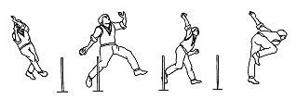

Models of Bowling
It appears that much of the cricket literature on bowling technique is generated purely from the experience of past players. Though there has been some excellent research into the biomechanics of injuries sustained by fast bowlers, most other attempts to understand the biomechanics of bowling have been limited to the analysis of kinematic and force plate data. This has played a part in the development of the bowling technique, but is inadequate to understand the underlying mechanics of bowling. The University of Waikato (Dept. of Physics & Electronic Engineering, and Dept. of Mathematics), Hamilton, is now generating the first mathematical models of bowling in an attempt to understand bowling techniques and thus improve coaching methods. A physical action, such as bowling a ball, is often difficult to understand if considered throughout in all its complexity. On the other hand, a simplified model of the event is much easier to study and understand. Thus, the human body can be represented as a system of interconnected rigid body segments subject to applied external forces and torques. A segment could be, for example, a forearm, a thigh or any other major body part attached by a hinge to others (Fig.2).
There are two general approaches of rigid body modelling within the field of classical dynamics: the direct method of analysis by applying Newton's laws to each of the individual parts of the system; or a more indirect method, which treats the system as a whole by using a comprehensive theory of mechanics based on energy principles. This latter method is known as Lagrangian mechanics, and can often be used to formulate a complete set of ordinary differential equations for the motion without solving explicitly for the constraint forces acting on the various parts of the system. It is characterised by its simplicity and is applicable in any suitable coordinates.
Figure 2: A multiple segment, Lagrangian rigid body model of bowling.
Inset shows how the system can be actuated by a selection of joint torques,
Ti, and choice of initial values for the generalised coordinates, qi..
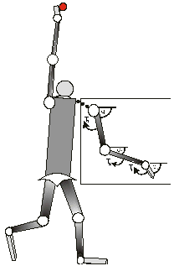
Once the Lagrangian equations for a particular bowling model have been generated, it becomes possible to investigate the dynamics for a variety of bowling actions. This process reveals several interesting features of the bowling technique. In fact, many of these are at odds with what is traditionally thought to constitute proper bowling technique. It is time, therefore, to allow biomechanics to dispel many of the myths that surround the bowling technique. However, this article is not intended to be the definitive account of bowling biomechanics. Research into bowling is still in its infancy and there is a long path to follow before many of its mysteries are revealed. What is presented here will help clear up some fundamental misunderstandings on the subject, and shed some light on the diverse and intricate field of bowling biomechanics.

The Biomechanics of Bowling
The high speed motion analysis systems at the University of Auckland (Dept. of Sport & Exercise Science) and the Waikato Polytechnic (Dept. of Sport & Exercise Science, Hamilton) were used to obtain kinematic data of various bowlers. By substituting this data into the Lagrangian equations of motion governing a particular bowling model, the joint torques could be calculated over time; thus giving a unique perspective into the dynamics of the bowling action.
Basic Action Type: There are two basic types of bowling action in cricket: the side-on action and the front-on action. The side-on bowler looks behind the front arm during delivery stride to sight the target, while the front-on bowler looks inside the front arm to achieve this end, causing the hips and shoulders to "open", and more or less face the batsman before delivery.
The side-on action has generally been considered the orthodox method of bowling, most likely to achieve the best results. This paradigm was further perpetuated by early research which suggested that the front-on action was more likely to put strain on the lower lumbar region, and therefore increase the risk of serious back injury. These findings were not in keeping with common experience, as at the time some of the world's most successful fast bowlers were from the West Indies, using predominantly front-on actions with a relatively low incidence of reported back injury. Fortunately, common sense did eventually prevail, and more recent research has vindicated the front-on action. Ironically, it may even be the safest action of them all!
However, there are still certain coaches who are suspicious of the front-on action. Often reasons such as reduced accuracy and lack of away movement are cited. Yet, there have been many great exponents of this form of bowling. Malcolm Marshall, Curtly Ambrose, Bob Willis, and Mike Procter - just to name a few - have proved that front-on bowlers can generate express pace [Fig. 6]. And then the magical wizard from Pakistan, Abdul Qadir, really confounded the critics, when he conclusively proved that leg-breaks could be bowled most destructively from a front-on action. Later, Mushtaq Ahmed, also from Pakistan, showed that even front-on leg-break bowlers with considerably less ability than Qadir, can still win Test Matches!
Figure 3: (Left) The great Abdul Qadir, bowling a vicious leg-break from a front-on action. (Right) Mushtaq Ahmed does not possess the same ability as Qadir, but on his day can still win Test Matches.
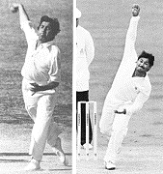
Photos: Courtesy of Patrick Eagar
Run-up: Determining the purpose of a bowler's run-up is relatively simple, but it is still subject to much confusion. There is a common belief that the main purpose of generating run-up speed is to make a simple additive contribution to ball speed at release. It is likened to the case where a person throws an object forwards out of a moving train. The faster the speed of the train, the faster the object is released relative to the earth.
Is there any evidence to suggest that the additive principle of run-up speed is indeed utilised by bowlers to a significant extent? Previous studies have indicated that the run-up speed of very fast bowlers during the penultimate stride is rarely above 20 km/h. In fact, Jeff Thomson probably the fastest bowler in the history of cricket only clocked up a run-up speed of 13.7 km/h during his penultimate stride. Considering that Thomson bowled his fastest balls at around 158 km/h, the additive contribution of his run-up is minimal.
Is the run-up therefore of minor importance to bowling? Or is there another principle at work? Simple Lagrangian models and studies of force plate data from javelin throwers indicate that the run-up generates ball speed by utilising the ground reaction forces to initially slow the lower body, and then use the front leg as a lever. When a bowler is forced to decelerate during delivery stride, the inertia of the upper body helps thust the trunk and bowling arm forward over a braced front leg.
So then why hasn't this reasoning been applied to the run-up? I am not sure, but it really does seem that the purpose of having a run-up is for the very reason that one has to stop! All good javelin throwers use this principle [Fig. 4]. Coaches should change their emphasis on how they analyse and perhaps design the ideal run-up of a bowler. They should design the length, speed and rhythm of a run-up so that the bowler can brake quickly using the ground reaction forces to create a solid base of support over which the upper body segments can catapult themselves forward. Only then can the momentum generated by the run-up be transferred to the ball.
Figure 4:
Javelin throwers and bowlers generate similar ground reaction forces during delivery stride. These are used to decelerate the speed of the lower body to create a solid base of support over which the upper body segments can catapult themselves forward. [After E. Deporte & B. van Gheluwe (1988) in G. de Groot et al. (eds) Biomechanics XI B, 575-581. Free University Press, Amsterdam]
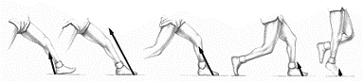
It must also be recognised that a run-up must be individually tailored to suit the individual bowler, and accommodate technical differences. For instance, previous studies have indicated that run-up approach speeds of front-on bowlers are significantly faster than their side-on counterparts. It may be destructive for a javelin-type bowler like Thomson to significantly increase his run-up speed based on the fact that Malcolm Marshall (a front-on bowler) runs in about twice at fast. Because a proper utilisation of the run-up is concerned primarily with optimising the braking power, what suits one bowler is unlikely to suit someone using a different action.
Figure 5:
Jeff Thomson, the fastest bowler in recorded history, was not only unique in the execution of his side-on javelin-type action, but in the short ambling run-up which preceded it. What he lacked in run-up speed, he made up in a greater range of trunk flexion, and good use of the ground reaction forces. [Picture from T. Lewis (Ed.) (1992), MCC Masterclass. The New MCC Coaching Book. Weidenfield and Nicholson, London].
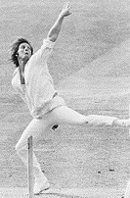
Photo: Courtesy of Patrick Eagar

Figure 6:
The late great West Indian paceman, Malcolm Marshall, not only proved that short men can bowl fast, but that a front-on action is an efficient means to do so. He did not extend the trunk laterally very much, but he did not need to, as he chose to generate much of his pace from a fast, explosive run-up. He also defied the established thought of the time, that outswingers could not be effectively bowled from a front-on action.
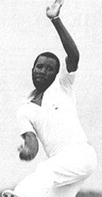
Trunk Flexion: Another critical feature in bowling technique, which is not properly understood, is the role of trunk flexion in the generation of ball release speed. It is commonly held that there is correlation between trunk flexion speed and ball release speed. Some coaches believe that the range of trunk extension-flexion angle is also important. Though these can be important factors, the reality of the trunk action in bowling is more complex.
During the delivery leap there is an initial trunk rotation and extension away from the intended direction of the ball. Once in delivery stride, the trunk begins to rotate and flex forwards pulling the bowling arm with it. However, there is a braking action on the trunk as it nears the end of its range of motion. By means of Newton's Third Law the braking action of the trunk segment further accelerates the bowling arm segments prior to ball release [Fig. 7]. Therefore, part of the reason why the trunk undergoes flexion is so that it can decelerate at the appropriate time during delivery stride. The braking action of the trunk is perhaps one reason why fast bowlers of similar speed can deliver the ball with significantly different trunk extension angles and trunk flexion rates.
Figure 7:
Idealised trunk and bowling torques in bowling. Clockwise is defined in the sense of rotating towards the batsman, so any braking torques will be represented as an anticlocwise (positive) torque. Contrary to common opinion, the bowling arm does not accelerate during trunk flexion, but only when the trunk undergoes a braking action. Note that the torques are not drawn to scale. In reality, trunk torques are many times greater than arm torques.
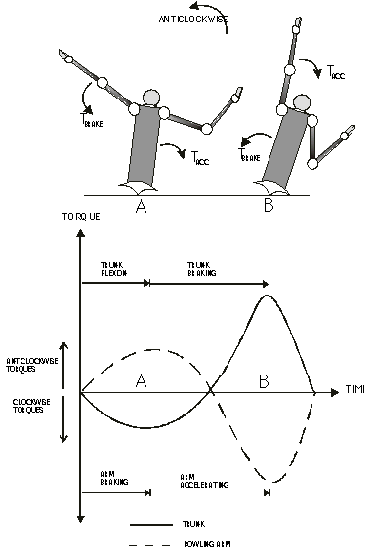
Action type also plays a major part in determining the amount of trunk flexion used to generate speed. Jeff Thomson, for instance, used to bowl with an exaggerated backward lean. Malcolm Marshall, on the other hand, bowled from a more vertical trunk position. In general, front-on bowlers do not extend the trunk as far as their side-on counterparts. They may not need to as they can probably utilise their run-ups more efficiently.
Non-bowling Arm: Conventionally, it is taught that the non-bowling arm should be held high during the delivery leap and then, from the time of back foot contact, be pulled down vigorously to aid in the generation of ball speed. However, this is only an approximation to what is really the case.
Figure 8:
For a simple 2D rigid body model of bowling, the anti-clockwise torques on the non-bowling arm tend to accelerate the flexion of the trunk in the direction of the batsman (A-B-C).
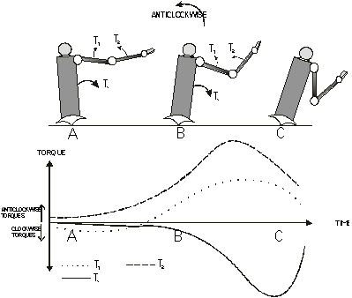
Contributing to the action of the trunk is the motion of the non-bowling arm, but the mechanics of front-arm motion is complex, and a simple mechanical treatment can only alleviate some of the confusion surrounding it. By simulating simple rigid body models of the trunk and non-bowling arm, it was shown that a clockwise torque exerted on the non-bowling arm produced an anticlockwise reactive torque on the trunk [Fig. 8]. This is contrary to what is generally taught: that a clockwise pulling-down motion of the non-bowling arm increases the rate of trunk flexion. Though it is anatomically necessary for the non-bowling arm to be pulled down somewhat, there should be more emphasis on its being pulled in towards the trunk, so that anticlockwise torques are placed on the non-bowling arm.
Still there are other aspects of non-bowling arm action, which have to be considered. For instance, in certain actions it appears that there are phases in which the bowling arm does not rotate independently of the trunk. There may be phases in the bowling action when the bowling arm and trunk move as "one-piece". When this occurs it is more appropriate to say that trunk flexion is aided because the centre of gravity of the upper body as a whole is shifted forward, rather than by any action of front arm torques [Fig. 9].
Figure 9:
Trunk flexion is not only dependent on the torques generated by the non-bowling arm, but also by arm configurations which determine the position of the centre of gravity for the whole upper body. In position B, the centre of gravity has been moved slightly forward making it easier to rotate the trunk clockwise about the hips than in position A.
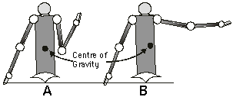
Also, the non-bowling arm should only be pulled in when the trunk is flexing. When the trunk undergoes its braking motion, it is vitally important that the action of the non-bowling arm is stopped. This is rarely taught properly, because bowlers are often cloned to tuck the non-bowling arm into the ribs during this time to forcibly retard its motion. However, there is plenty of pictorial evidence to suggest that great bowlers, past and present, use a variety of methods to retard the non-bowling arm [Fig. 10]. Shane Warne blocks his front arm on the front leg during delivery stride. Contrast this with Dennis Lillee who seems to retard the front arm beside the left side of his body.
Figure 10:
(Top left) Dennis Lillee, arguably the greatest fast bowler of all time, is pictured here retarding his front arm beside his body. (Top right) Mike Proctor from South Africa, seems to bowl with a science of his own - there is no forcible retardation of the front arm evident. (Bottom left) Schwarz, South Africa's earliest leg-breaking champion, braced his front arm across the front leg. (Bottom right) Shane Warne, Australia's most successful leg-break bowler, at times uses a similar strategy to Schwarz. Notice the similarity in their positions.
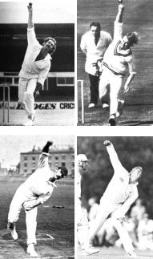
Photos (TR & BR) by Patrick Eagar
Rear Hip: The correct action of the rear hip is one of the most important aspects of bowling. However, what is "correct" in this case is very difficult to determine. There is variation among successful bowlers. But in general, by accelerating the hip forward with a flexed knee, the bowler is likely to feel two effects: (1) a reactive force pulling the trunk towards it, and (2) a deceleration in the rotation of the bowling arm. So, for instance, if during a phase of the bowling action, the bowling arm is accelerating relative to the trunk, then the hip action should be retarded, as this would tend to decelerate the bowling arm [Fig. 11].
Figure 11:
Bishen Bedi, who bowled finger-spin with an almost mystical artistry, is shown here retarding the rear hip as the arm accelerates relative to the trunk. The observer can generally infer that the arm is accelerating relative to the trunk when the front arm is in the process of retarding the rate of trunk flexion.
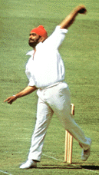
Photo by Patrick Eagar
This may reflect the situation for many finger-spinners, who can use more arm in their actions than other forms of bowling. The common teaching, therefore, to thrust the rear hip forward early with the knee bent once front foot contact without any consideration for the type of bowler, is technically erroneous and potentially damaging to bowling performance [Fig. 12]. Correct hip action is a subtle art requiring exquisite timing, and the mechanics behind it is still not well understood.
Figure 12:
Two great Australian off-spinners from vastly different eras: Ashley Mallett (left), and Monty Noble (right) are shown to be in almost identical positions after release. Note how the right knee is bent, but has not yet past the front leg even at this late stage of the action.
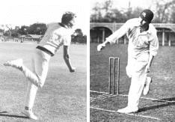
Front Knee Action: Coaches are often found admonishing young bowlers with the famous catch phrase " bowl over a braced front leg". This is an unfortunate situation, as the action of the front knee during delivery stride is complicated to understand mechanically. In fact, it is extremely difficult to determine the optimum knee action in bowling, and most likely, correct knee action is going to vary with the type of bowler and style of delivery.
Theoretically, apart from perhaps giving the bowler a slight leverage and height advantage, bracing the front leg causes a slight deceleration in trunk flexion. This means that if a bowler is to adopt a "braced front leg" technique, it must be executed during the phase of trunk deceleration for maximum efficiency. This is difficult to do if it is not natural, and that is why so many successful bowlers do bowl over a bent front knee - Wasim Akram, Andy Roberts, Bill O'Reilly, and Dennis Lillee - just to name a few! However, this is not to say that bracing the front leg should be discouraged. Only that coaches have to be aware that there is no one optimal knee action for all bowlers, and that careful consideration must be given before any changes are made here.

The Reality of Bowling: Technical Diversity
It is evident from what has been discussed in this article so far, that bowling is a complex activity, which lends itself to a diverse range of techniques. This is because the act of bowling is said to be redundant, i.e. an infinite set of joint positions can lead the end effector (in this case the hand) to the same location. This same property can be demonstrated if you sit at a table and place a glass in front of you so that it can be easily picked up with a bent arm. Notice how there are a variety of joint configurations that would allow you to carry out this task. This is somewhat the same case for the bowler trying to deliver a ball. There are many modes of delivery available.
So how many different types of allowable actions are there? An infinite number? Perhaps not, but lets run a simple example using an elementary combinatorial method to see if we can get a qualitative feel for the technical diversity in bowling. Let's assume that there are three allowable hip and shoulder alignments - closed, partially open (450), and open; two allowable front knee angles at ball release - straight (or braced) and bent; two different front-arm positions at back foot contact - bent and straight; two heights of the front knee at back foot contact - high and low; two positions at which the bowling arm straightens (or locks) - early and late; three different orientations of the front hand at back foot contact - towards the off-side, towards the batsman, and towards the umpire; two different lifting actions of the rear leg during delivery - late and early; three lengths of delivery stride - short, medium and long; three varieties of bowling arm action - rotary windmill-type (hand has circumscribed two revolutions by release), standard type (hand starts in front of face or shoulder), and javelin-type (hand starts behind right hip). Considering only these variations, how many allowable actions are there? The answer is 3x2x2x2x2x3x2x3x3, which gives a staggering 2592!
Imagine that! There are so many distinct ways of delivering a cricket ball, even when only the most basic of variations are considered. Of course, there are likely to be interrelationships between some of the technical variations. For instance, javelin-type actions are most likely to be used with closed hip and shoulder alignments. Such interrelationships will reduce the number of allowable actions. However, only the most basic variations have been considered here. For instance, the technical variations associated with spin and swing have not been considered. In reality, the number of allowable actions will be significantly higher, especially when the effects of individual differences in anthropometery are taken into account.
Figure 13:
Diverse bowling styles. (Top left) Bob Willis, former England fast bowler - he ran in to bowl like a "chook". (Top right) Max Walker, from Australia, said to be so ungainly when he bowled that he was nicknamed "tangles". (Bottom left) Colin Blythe demonstrates a unique pre-delivery position. (Bottom right) Cottrell, one of the fastest bowlers in the world in the early 1900s, used a javelin-type action similar to Thomson.
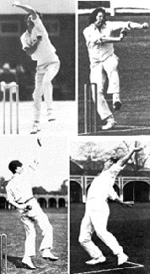
Photo TL: Courtesy of Patrick Eagar
It may be argued that these variations are mainly stylistic in nature, and have little to do with the biomechanical efficiency of the bowling action. For some variations observed in bowlers, this may be the case; but certainly not for the fundamental variations just considered here. Also, when the bowling action is modelled mathematically, it has been found that many of the movements in bowling which are often dismissed as merely stylistic embellishments have actually been found to play a critical biomechanical role in the delivery of the ball.

Conclusion
Bowling is an art that cannot be reduced to a rigid set of mechanical principles. Ironically, it is only a proper application of biomechanics to bowling which reveals this. There is likely to be opposition to this point of view, because by nature people are uncomfortable when things cannot be concretely conceptualised. Einstein once said, "Make things as simple as possible, but no simpler!" Coaches often confuse "simple" with "simplistic" in their bid to reduce the art of bowling to understandable proportions. This is like trying to completely understand the art of classical music composition by developing a set of simple mathematical formulae for melody.
Yet others may be angered by the thought that the author proposes some sort of bowling anarchy, where anything goes. They would claim that coaching bowlers could become impossible - bowling is just to complex; no-one knows thousands of actions! And even if they did, who is to know which one suits whom. And this is my point exactly! The coaching of bowlers is an art too! There are often no easy answers! It requires the coach to have an in depth knowledge of the art of bowling, and this is somewhat dependent on the coach's playing experience and level of intuition. Without these, a coach could do more harm than good!
Bowling is a dynamic, flexible and creative art, where the participant takes part in a sort of rhythmic dance. In the past, there have been attempts to use science to reduce bowling to a set of recipe-like instructions. Perhaps this is what is causing many young bowlers to suffer serious back injuries? However, in the future, if biomechanics is utilised correctly to explain technical diversity rather than to shun it, then the art of bowling will be rediscovered, and displayed in all its wonder throughout the cricketing world and beyond.

